**Expt. No.:**

**Date :**

**Common Emitter RC Coupled Amplifier**

**Aim:-**

To design and set up a common emitter RC coupled amplifier.

**Components / equipments required:-**

|  |  |  |  |
| --- | --- | --- | --- |
| **Sl. No** | **Components / equipments** | **Specification** | **Quantity** |
| 1 | Transistor | BC 107 | 1 |
| 2 | Capacitors | 47 µF | 1 |
| 10 µF | 2 |
| 3 | Resistors | 2.7 KΩ | 1 |
| 2.2 KΩ | 1 |
| 15 KΩ | 1 |
| 560 Ω | 1 |
| 4 | CRO | 30 MHz | 1 |
| 5 | Function Generator | 2 MHz | 1 |
| 6 | Probes |  | 3 |
| 7 | DC Source | 0-30 V dual power supply | 1 |
| 8 | Bread Board |  | 1 |

**Theory:-**

In common emitter amplifier, AC input signal to be amplified is applied between base and emitter terminals. The output is taken from the collector through the coupling capacitor. The emitter-base junction must be forward biased and the collector-base junction must be reverse biased for the proper functioning of a transistor as an amplifier. Base current controls the collector current of a common emitter amplifier. A small variation of base current makes a large variation in the collector current by a factor β. It gives a faithful amplification of input AC signal. For a distortion-less output the operating point must be fixed at the middle of the load line by selecting VCE = 50% of VCC.

Resistors R1 and R2 provide necessary biasing for the circuit. They form voltage divider biasing which requires only one power supply. The voltage across R2 i.e. is used to forward bias emitter base junction.VCC through RC reverse biases the collector base junction. Resistor RE is used to avoid thermal runaway and thus it provides thermal stabilization.

Input AC signal is applied to the base of the transistor through an input capacitor $C_{C_{1}}$. This capacitor allows only AC signal to enter the base. Thus it prevents any DC component from affecting the biasing conditions of transistor. Coupling capacitor $C_{C_{2}}$ is used to couple one stage of amplifier to the next stage. It allows only amplified AC signal to pass to the next stage but blocks the DC voltage. Therefore it is also called blocking capacitor. If this capacitor is not used, the biasing conditions of the next stage will be drastically changed due to DC component from the first stage. Capacitor connected across the emitter resistance RE is called emitter bypass capacitor. It is called so, since it provides an easy path to the AC emitter current and allows it to pass on instead of flowing through RE. If this capacitor is not used, AC emitter current will flow through RE causing an AC voltage drop across it. This voltage will produce a feedback effect and thereby reduce the output voltage. To bypass even the lowest frequencies, emitter bypass capacitor with reactance $X_{C_{E}}=\frac{R_{E}}{10}$ is used.

RC coupled CE amplifier is widely used in audio frequency applications, in radio and TV receivers. It provides current, voltage and power gains.

**Procedure:-**

1. Design the circuit.
2. Connect the transistor biasing circuit and verify the DC biasing conditions.
3. Connect the remaining part of circuit as per the circuit diagram.
4. Observe the amplified output on CRO.
5. Vary the input frequency from 50 Hz to 2 MHz and note down the output voltage.
6. Plot the graph with log f on X-axis and gain in dB along Y-axis.
7. Mark a point on the graph at 3dB less than the maximum gain. Extend the points to X-axis and mark the cut off frequencies, $f_{L}$ and $f_{H}$.

**Design:-**

$$Design of amplifier section:$$

$$Let V_{CC}=12V, I_{C}=2mA, β=100, S=5$$

$$V_{CE}=50\% of V_{CC}=6V$$

$${ V}_{RC}=40\% of V_{CC} = 4.8V$$

$${ V}_{RE}=10\% of V_{CC}=1.2V$$

$$R_{C}=\frac{V_{RC}}{I_{C}}=\frac{4.8V}{2mA}=2400≅2.2KΩ std$$

$$I_{E}≅I_{C}=2mA$$

$$R_{E}=\frac{V_{RE}}{I_{E}}=\frac{1.2V}{2mA}=600≅560Ω std$$

$$S=\frac{\left(1+β\right)\left(1+\frac{R_{th}}{R_{E}}\right)}{\left(1+β+\frac{R_{th}}{R_{E}}\right)} where R_{th}=R_{1} ‖⃦ R_{2}$$

$$5=\frac{\left(1+100\right)\left(1+\frac{R_{th}}{560}\right)}{\left(1+100+\frac{R_{th}}{560}\right)}⇒R_{th}=2343.9Ω$$

$$Also V_{R_{2}}= V_{BE}+V_{RE}=0.7+1.2=1.9V$$

$$V_{R_{2}}=V_{CC}\frac{R_{2}}{R_{1}+R_{2}}$$

$\frac{R_{2}}{ R_{1}+R_{2}}=\frac{V_{R_{2}}}{V_{CC}}=\frac{1.9}{12}=0.158$ (1)

$\frac{R_{1}R_{2}}{R_{1}+R_{2}}=2343.9$ (2)

$From \left(1\right) and \left(2\right), { R}_{1}=14803Ω ≅15KΩ std$

$$R_{2}=2820.6Ω ≅2.7KΩ std$$

$Design of Capacitors:$

$${Reactance of emitter bypass capacitor, X}_{C_{E}}=\frac{R_{E}}{10}=\frac{560}{10}=56Ω$$

$$X_{C_{E}}=\frac{1}{2πfC_{E}}$$

$$Take f=50Hz so that C_{E} bypasses all frequencies above 50 Hz$$

$$C_{E}=\frac{1}{2πfX_{C_{E}}}=\frac{1}{2π×50×56}=56.84μF≅47μF std$$

$$Assume coupling capacitor, C_{C_{1}}= C_{C_{2}}=10μF$$

**Result:-**

Designed and set up a common emitter RC coupled amplifier and sketched the waveforms and frequency response.

Bandwidth =

**Circuit Diagram:-**

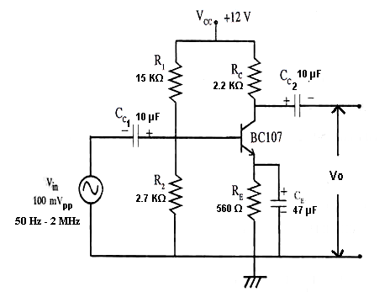

**Expected Waveforms and Frequency Response:-**

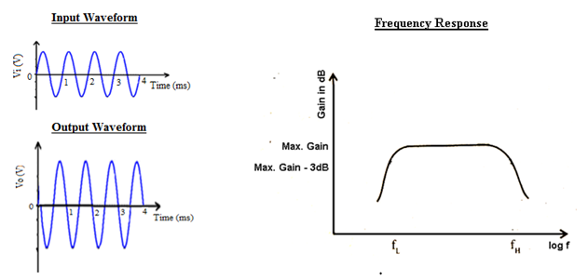

**Observations:-**

Vin =100 mVpp

|  |  |  |  |
| --- | --- | --- | --- |
| f(Hz) | log f | V0(V) | AV(dB)=20log |
|  |  |  |  |
|  |  |  |  |
|  |  |  |  |
|  |  |  |  |
|  |  |  |  |
|  |  |  |  |
|  |  |  |  |
|  |  |  |  |
|  |  |  |  |
|  |  |  |  |
|  |  |  |  |
|  |  |  |  |
|  |  |  |  |
|  |  |  |  |
|  |  |  |  |
|  |  |  |  |
|  |  |  |  |
|  |  |  |  |
|  |  |  |  |
|  |  |  |  |
|  |  |  |  |
|  |  |  |  |
|  |  |  |  |
|  |  |  |  |